RUDDER REPAIRS

Over the last few years I have been having difficulty lowering the rudder on my Skipper 17 "Mischief". It is of the usual design with two lines for pulling the blade up or down.
Once the blade kicks up, for whatever reason, it was impossible to force it down again using the line intended for the purpose, and meant hanging over the stern and pushing it down by hand. This usually resulted in a wet sleeve and/or bruised ribs.

My first thought was to provide a notch in the trailing edge of the rudder blade so that I could engage a purpose made short boat hook to push it down, then use the line to make it secure. (Fig.1)

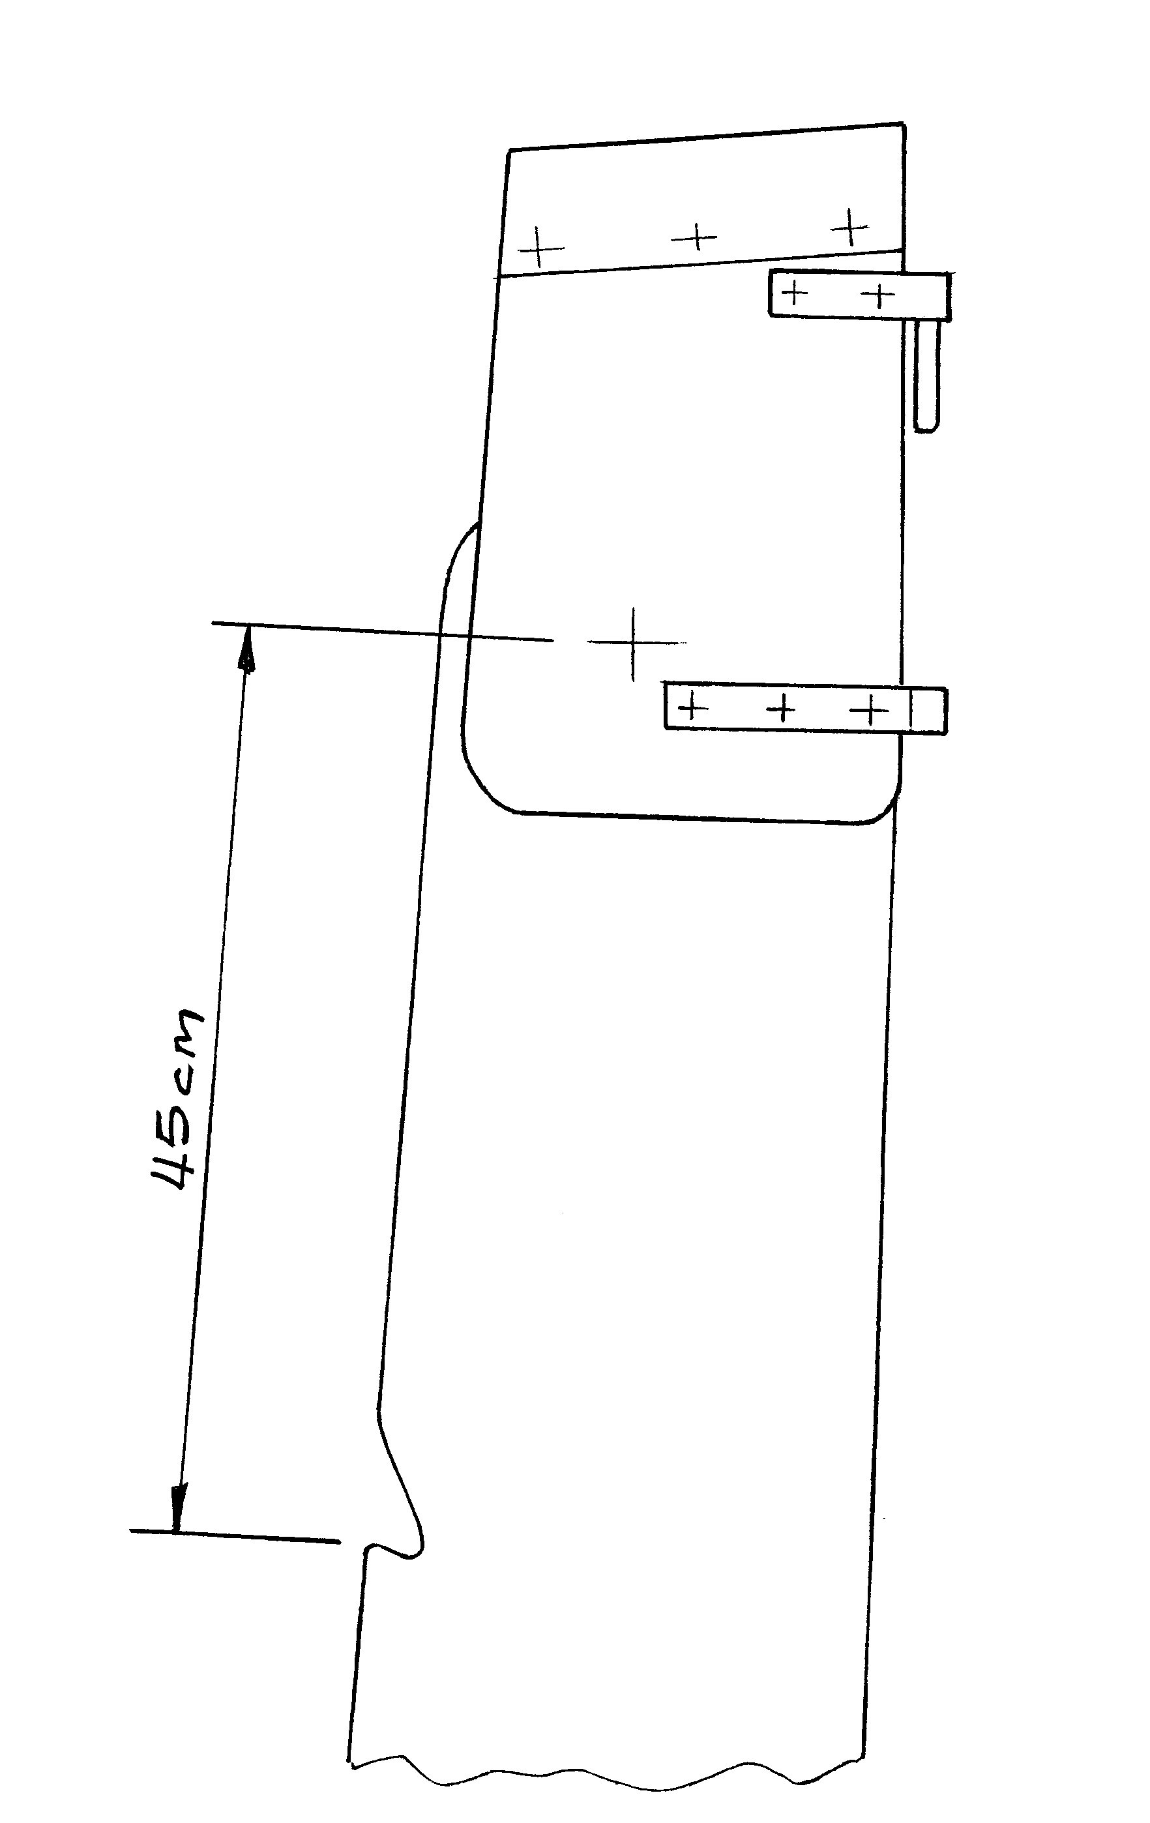
Fig.1

This worked well but it was still difficult to pull the line through to keep the blade down. I decided to dismantle it to see what could be done.

There were two problems, one being the path the line had to take over two sharp edges and through a slot under the tiller and the other was the pivot itself.

The line had worn deep grooves in the edges of the wood (Fig.2) and this was creating a lot of friction.

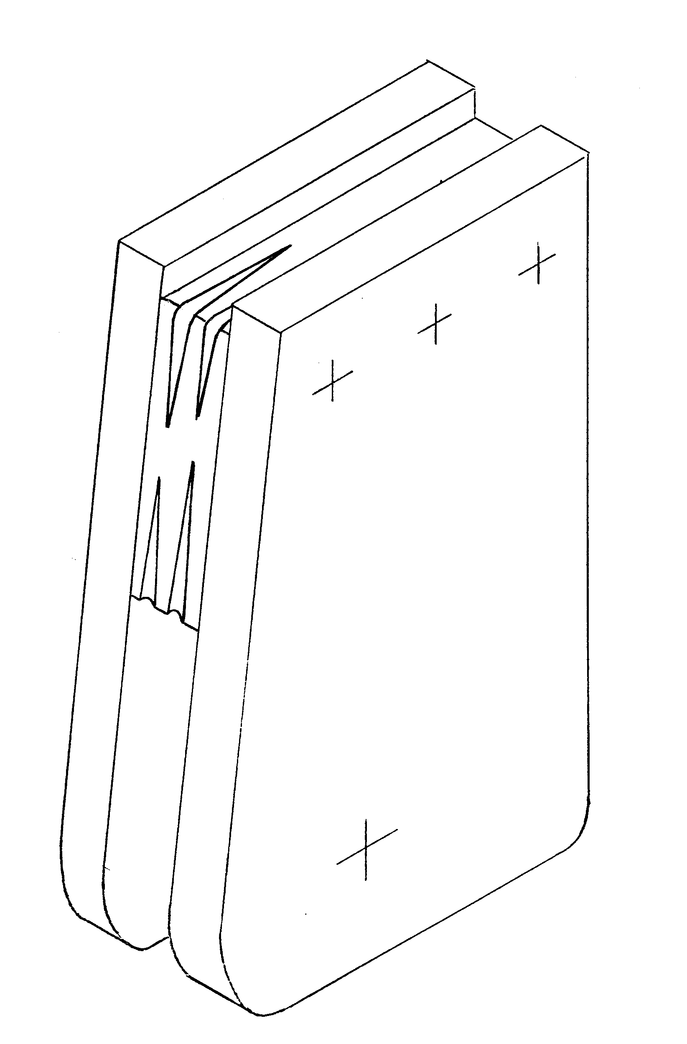
Fig.2

After several ideas including rollers etc. I decided to keep it really simple and fit two brass plates to protect the wood and cut down on friction. (Fig.3)
They only needed one countersunk screw each to hold them in place.
The grooves in the wood were filled with plastic wood and recesses cut so that the brass would lie flush.

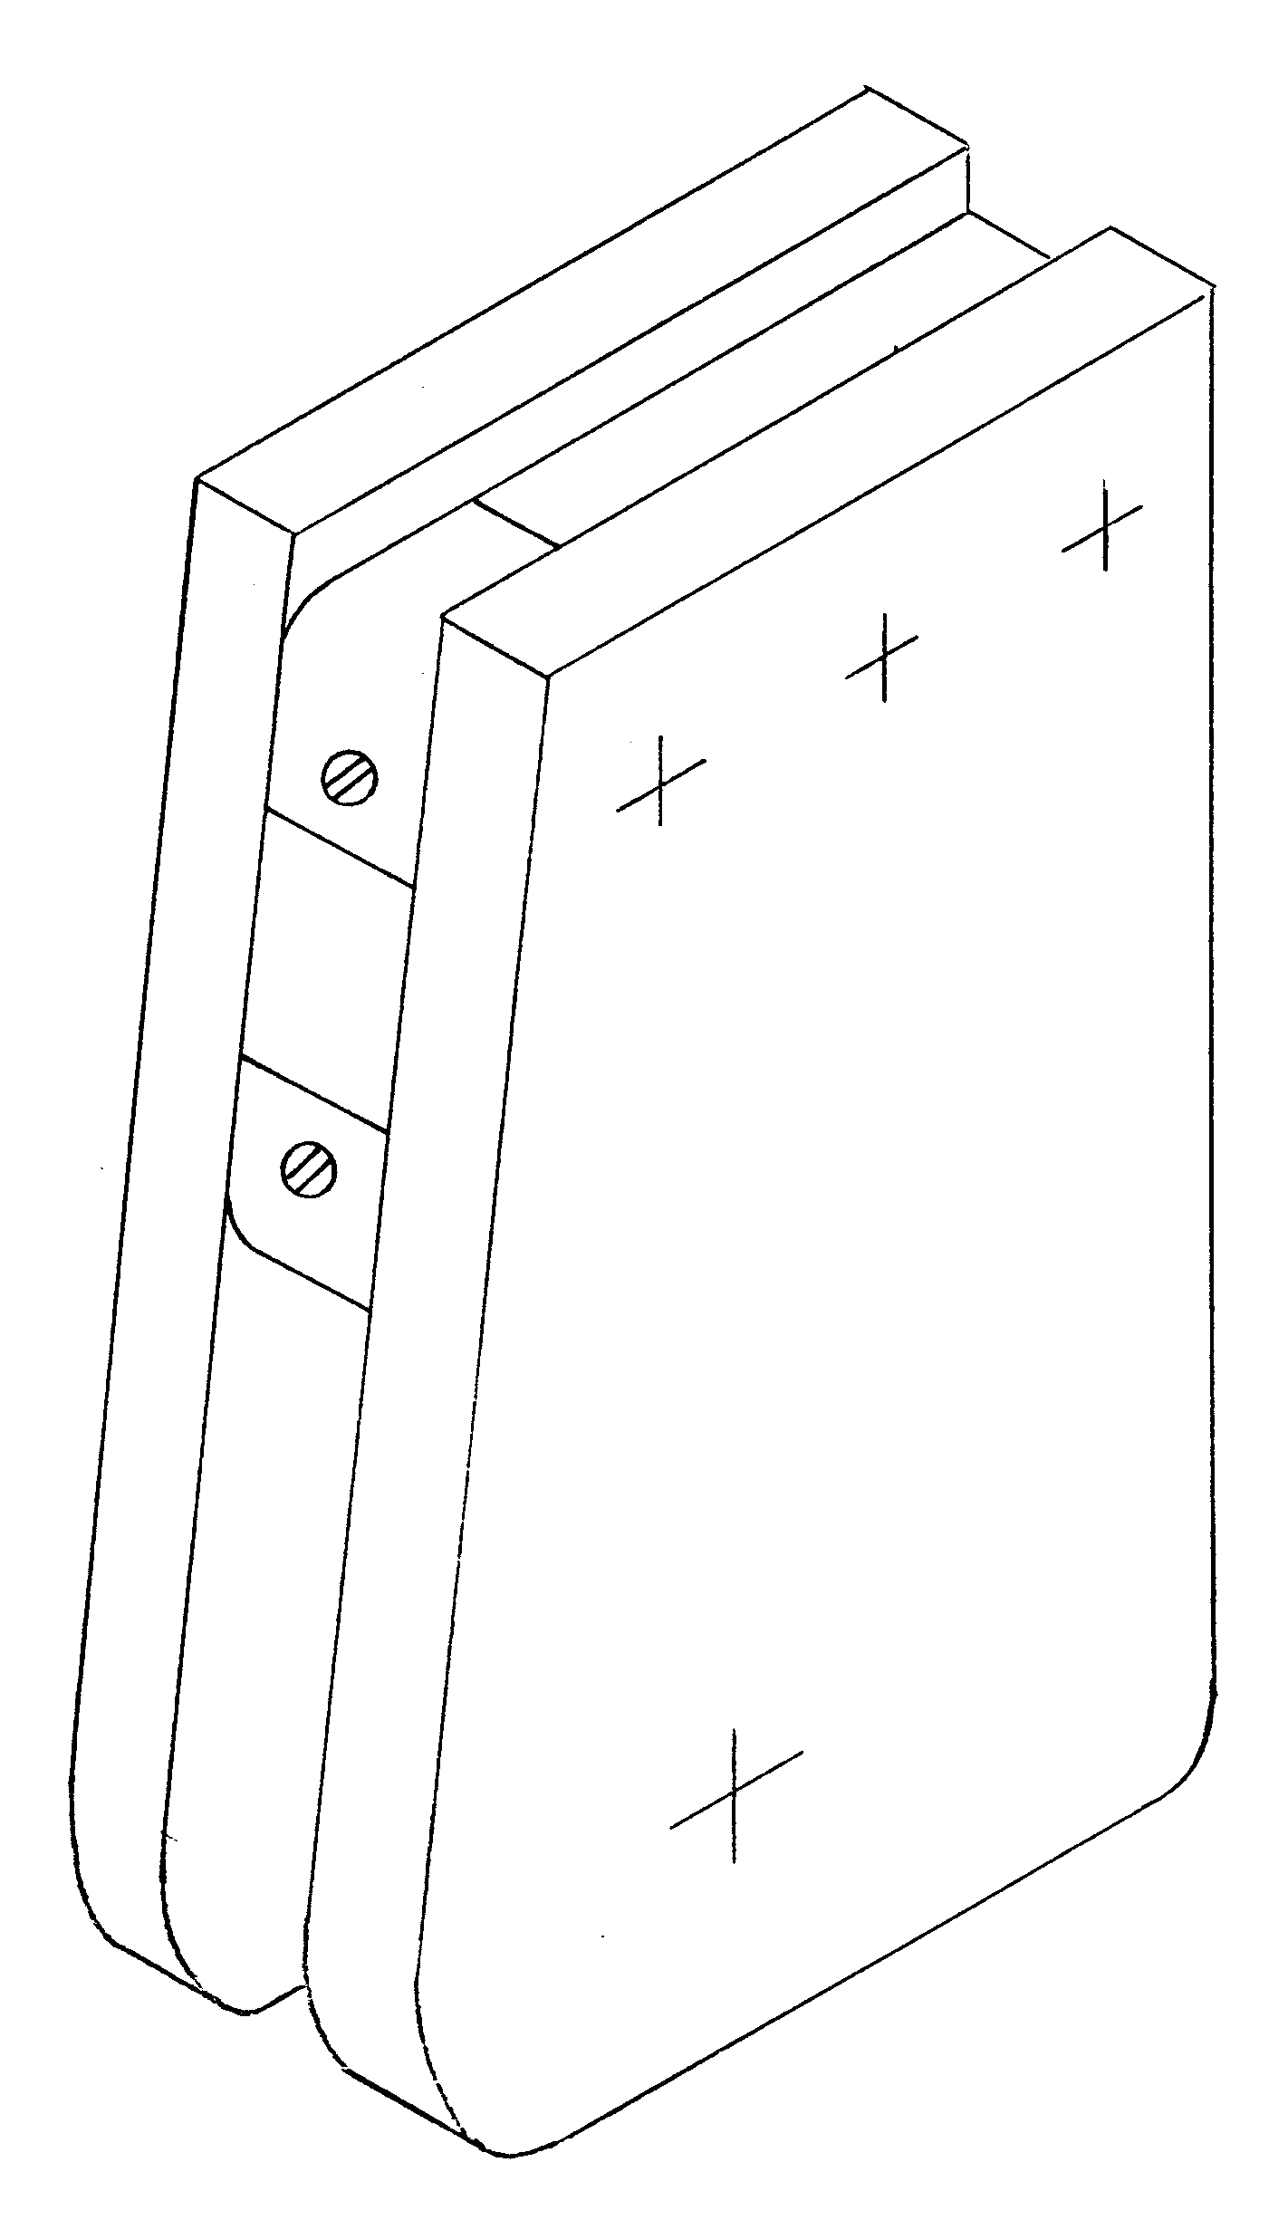
Fig.3

Next came the pivot. The hole in the blade had worn oval, also the bolt could be over tightened and this tended to trap the blade. It needed a spacer of the correct length so that the bolt could be tightened up without putting any pressure on the blade.
I turned up a brass tube 7/8" Dia. with a clearance hole through it for the bolt. I then glued a plug (with a pilot hole) into the stock so that it could be bored out accurately for the brass tube.

This now left the blade to be opened out to fit the tube. Thinking that this would also wear over time I opened the hole to 1 1/8" and fitted a Tufnol bush to fit over the tube. (Fig.4)

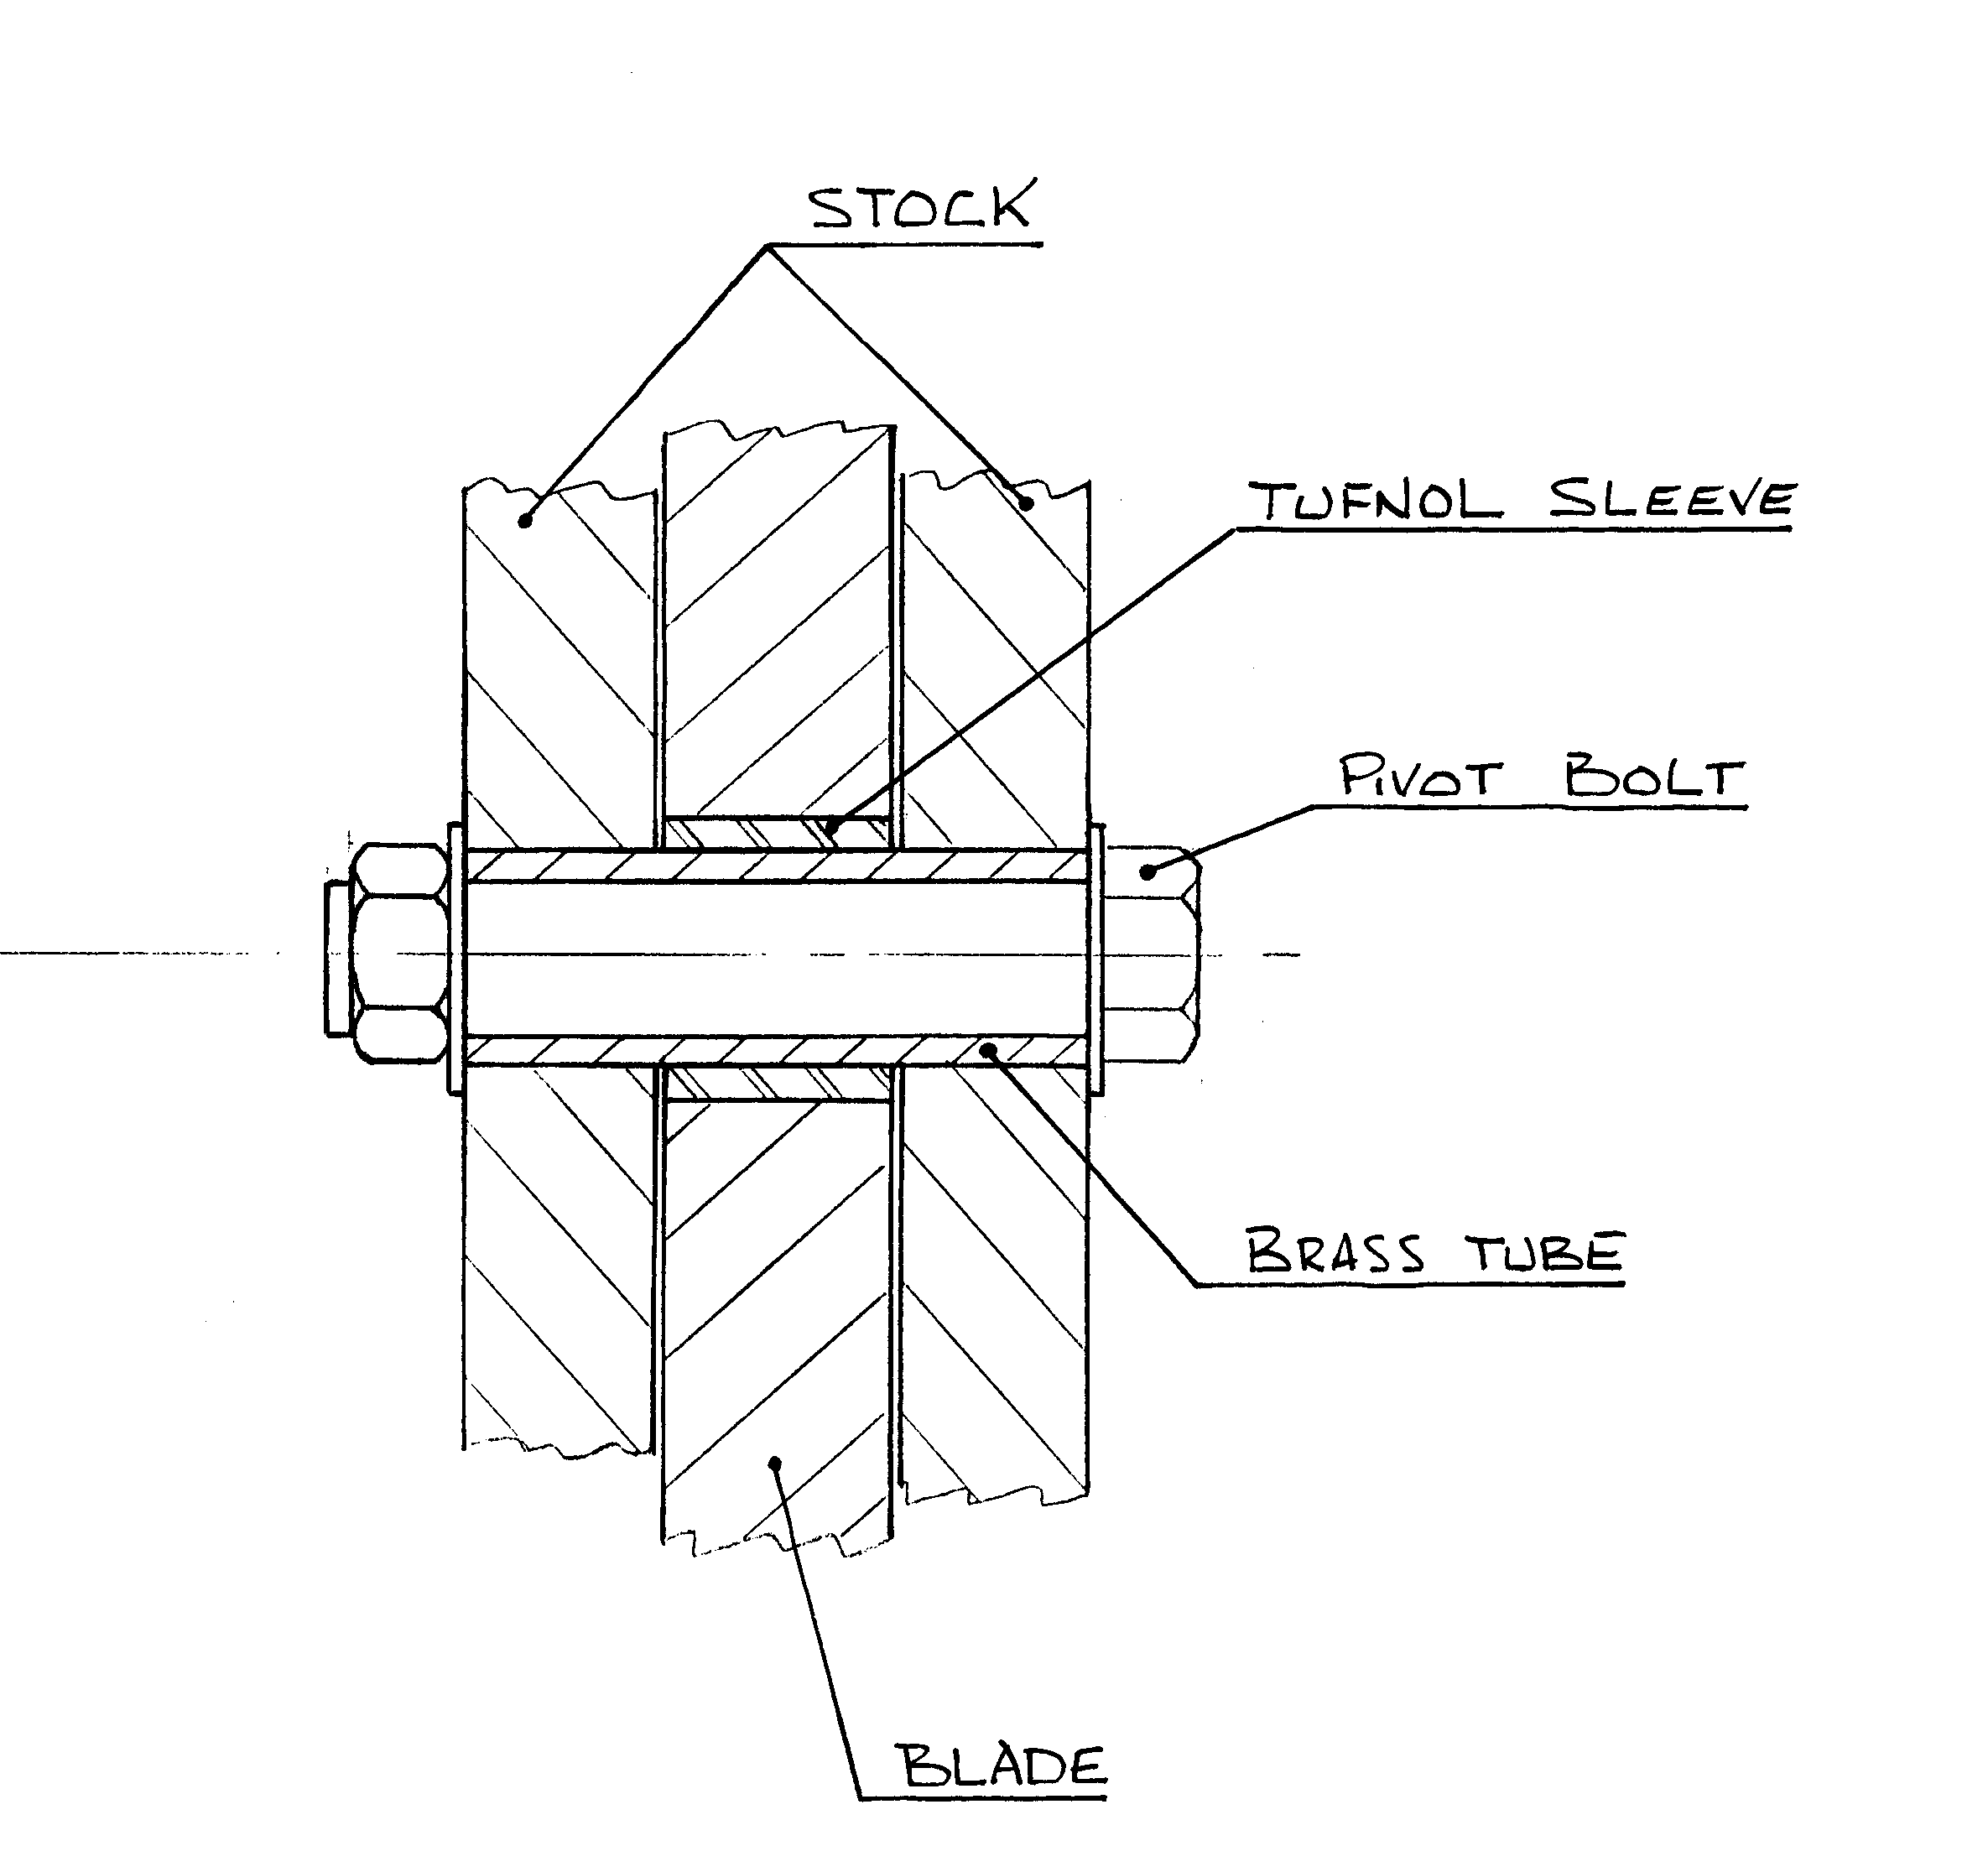
Fig.4

This now means that the bolt can be done up nice and tight without putting any pressure on the blade.

All this has certainly made it easier to pull the blade down using the line but if there is any way on the boat I still use the short boat hook.

David J Smith
Mischief (350)

